**Table Details:**

**The table name is BabyNames and the Columns are: ID ( INT, Primary Key), name (Text), gender (Text) , year (INT) and count (INT).**

**Query Results:**

**Query 1: Retrieve the top 10 most popular names for 2020.**

SELECT *

FROM babynames

WHERE year = '2020'

ORDER BY count DESC

LIMIT 10;

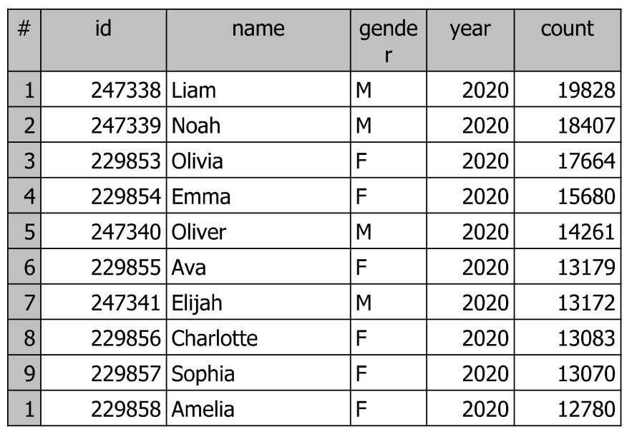

**Query 2: Find the total count of baby names for each gender in 2022.**

SELECT

COUNT(*) AS 'Female names'

FROM babynames

WHERE year = 2022 and

gender = 'F';

Result =

17660

SELECT

COUNT(*) AS 'Male names'

FROM babynames

WHERE year = 2022 and

gender = 'M';

Result = 14255

**Query 3: Identify the least common names used for each gender in 2015.**

SELECT *

FROM babynames

WHERE year = 2015 and

gender = 'M'

ORDER BY count

Limit 3000;

SELECT *

FROM babynames

WHERE year = 2015 and

gender = 'F'

ORDER BY count

Limit 3000;

3000 least common names are displayed for each gender.

**Query 4: Calculate the average frequency of your name across all available years to determine the trend in the past decade.**

SELECT name, year, count,

COUNT(name) AS frequency

FROM babynames

Where name = 'Edward'

GROUP BY year, name, count

ORDER BY year, name, count DESC;

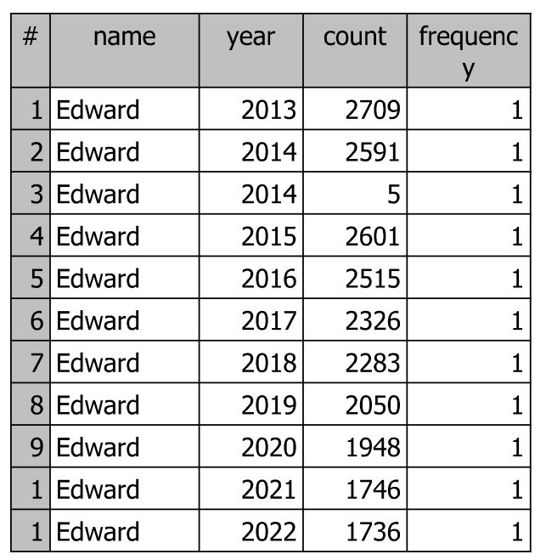

Used at a low frequency with the highest year being 2013 and the lowest being 2022 with the exception of 5 females using that name in 2014. All of the rest were males.

**Query 5: Determine the names that have consistently ranked in the top 100 regardless of the gender for the past 10 years.**

SELECT name, year, count,

DENSE_RANK() OVER(ORDER BY count DESC) Rank

FROM babynames

LIMIT 100;

Sophia is the number one ranked name.

|  |  |  |  |
| --- | --- | --- | --- |
| Sophia | 2013 | 21244 | 1 |
| Emma | 2013 | 20958 | 2 |
| Emma | 2014 | 20958 | 2 |
| Liam | 2019 | 20601 | 3 |
| Emma | 2015 | 20478 | 4 |
| Liam | 2022 | 20456 | 5 |
| Liam | 2021 | 20365 | 6 |
| Liam | 2018 | 19957 | 7 |
| Emma | 2017 | 19857 | 8 |
| Olivia | 2014 | 19829 | 9 |
| Liam | 2020 | 19828 | 10 |
| Olivia | 2015 | 19717 | 11 |
| Noah | 2015 | 19666 | 12 |
| Emma | 2016 | 19536 | 13 |
| Olivia | 2016 | 19397 | 14 |
| Noah | 2014 | 19329 | 15 |
| Noah | 2016 | 19171 | 16 |
| Noah | 2019 | 19145 | 17 |
| Liam | 2017 | 18849 | 18 |
| Noah | 2021 | 18849 | 18 |
| Emma | 2018 | 18801 | 19 |
| Olivia | 2017 | 18763 | 20 |
| Sophia | 2014 | 18636 | 21 |
| Noah | 2022 | 18621 | 22 |
| Olivia | 2019 | 18549 | 23 |
| Liam | 2014 | 18478 | 24 |
| Noah | 2017 | 18473 | 25 |
| Olivia | 2013 | 18446 | 26 |
| Noah | 2020 | 18407 | 27 |
| Noah | 2018 | 18403 | 28 |
| Liam | 2015 | 18400 | 29 |
| Noah | 2013 | 18276 | 30 |
| Liam | 2016 | 18259 | 31 |
| Jacob | 2013 | 18185 | 32 |
| Liam | 2013 | 18150 | 33 |
| Olivia | 2018 | 18039 | 34 |
| Olivia | 2021 | 17798 | 35 |
| Mason | 2013 | 17721 | 36 |
| Olivia | 2020 | 17664 | 37 |
| Isabella | 2013 | 17663 | 38 |
| Sophia | 2015 | 17445 | 39 |
| Mason | 2014 | 17212 | 40 |
| Emma | 2019 | 17194 | 41 |
| Isabella | 2014 | 17125 | 42 |
| Jacob | 2014 | 16904 | 43 |
| William | 2014 | 16839 | 44 |
| Mason | 2015 | 16657 | 45 |
| William | 2013 | 16654 | 46 |
| Olivia | 2022 | 16573 | 47 |
| Ava | 2015 | 16399 | 48 |
| Ava | 2016 | 16338 | 49 |
| Ethan | 2013 | 16254 | 50 |
| Sophia | 2016 | 16171 | 51 |
| Ava | 2017 | 16005 | 52 |
| Jacob | 2015 | 15979 | 53 |
| William | 2015 | 15935 | 54 |
| William | 2016 | 15798 | 55 |
| Ethan | 2014 | 15737 | 56 |
| Ava | 2014 | 15721 | 57 |
| Emma | 2020 | 15680 | 58 |
| Isabella | 2015 | 15646 | 59 |
| Michael | 2013 | 15530 | 60 |
| Emma | 2021 | 15510 | 61 |
| Michael | 2014 | 15487 | 62 |
| Alexander | 2014 | 15437 | 63 |
| Mason | 2016 | 15282 | 64 |
| Ava | 2013 | 15265 | 65 |
| Isabella | 2017 | 15231 | 66 |
| Ethan | 2015 | 15095 | 67 |
| Oliver | 2022 | 15076 | 68 |
| William | 2017 | 15023 | 69 |
| Ava | 2018 | 15010 | 70 |
| Mia | 2015 | 14927 | 71 |
| Sophia | 2017 | 14925 | 72 |
| Alexander | 2013 | 14918 | 73 |
| James | 2016 | 14905 | 74 |
| James | 2015 | 14857 | 75 |
| Isabella | 2016 | 14846 | 76 |
| Jayden | 2013 | 14782 | 77 |
| Oliver | 2021 | 14683 | 78 |
| Benjamin | 2016 | 14673 | 79 |
| William | 2018 | 14633 | 80 |
| Alexander | 2015 | 14569 | 81 |
| Isabella | 2018 | 14548 | 82 |
| Jacob | 2016 | 14544 | 83 |
| Ava | 2019 | 14528 | 84 |
| Michael | 2015 | 14474 | 85 |
| James | 2014 | 14456 | 86 |
| Mia | 2016 | 14452 | 87 |
| Emma | 2022 | 14435 | 88 |
| James | 2017 | 14346 | 89 |
| Daniel | 2013 | 14311 | 90 |
| Oliver | 2020 | 14261 | 91 |
| Michael | 2016 | 14120 | 92 |
| Logan | 2017 | 14042 | 93 |
| Sophia | 2018 | 13991 | 94 |
| Elijah | 2016 | 13956 | 95 |
| Oliver | 2019 | 13953 | 96 |
| Daniel | 2014 | 13949 | 97 |
| Elijah | 2014 | 13865 | 98 |